
Sec 5.4a –Trigonometry
Sine Wave Origin Name:
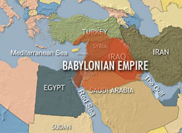
- The Babylonian Degree method of measuring angles. Around 1500 B.C. the Babylonians are credited with first dividing the circle up in to 360̊. They used a base 60 (sexagesimal) system to count (i.e. they had 60 symbols to represent their numbers where as we only have 10 (a centesimal system of 0 through 9)). So, the number 360 was convenient as a multiple of 60. Additionally, according to Otto Neugebauer, an expert on ancient mathematics, there is evidence to support that the division of the circle in to 360 parts may have originated from astronomical events such as the division of the days of a year. So, that the earth moved approximately a degree a day around the sun. However, this would cause problems as years passed to keep the seasons accurately aligned in the calendar as there are 365.242 actual days in a year. Some ancient Persian calendars did actually use 360 days in their year further supporting this idea.
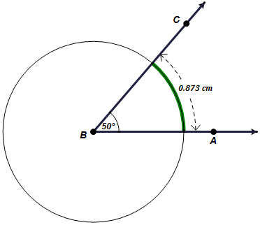
- The transition to Radian measure of angle: Around 1700 in the United Kingdom, mathematician Roger Cotes saw some advantages in some situations to measuring angles using a radian system. A radian system simply put, drops a unit circle (a circle with a radius of 1) on to an angle such that the center is at the vertex and the length of the intercepted arc is the radian measure. So, a full circle of 360̊ is equivallent to 2π∙(1) radians. In the example at the right, an angle of 50̊ is shown. Then, a circle that has a radius of 1 cm is drawn with its center at the vertex. Finally, the intercepted arc length is determined to be approximately 0.873 or more precisely $\frac{5π}{18}$ radians.
1 cm

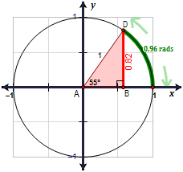

- How Right Triangles create a WAVE: First consider a right triangle drawn inside of a unit circle like the one shown at the right. Determine the value of $sin\left(A\right)$. Try the example at the right find $sin\left(55°\right)$ which is approximately the same as finding $sin\left(0.96 rads\right)$.

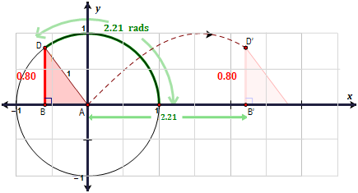

Then, if we plot each of point where x is the measure of the angle of the unit circle in radians and y is value of $sin\left(A\right)$ which is essentially the height of the right triangle for the given angle. The resulting locus of points generates a Sine Wave. Below shows several right triangles mapping out a s sine wave.

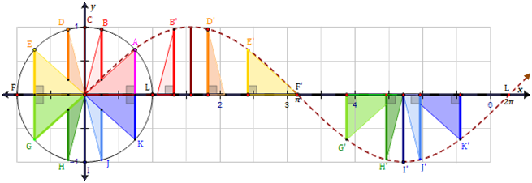

Student Worksheets: Matthew M. Winking at Phoenix High School SECTION 5-4 p.60

Sec 5.4b–Trigonometry
Sine Wave Origin Name:
A Sine Wave is commonly described by 4 components.
Parts of a Sine Wave | Visual
Amplitude: The amplitude of a wave is the distance from the midline to highest point of the wave. (half of the vertical displacement.  $Amplitude= \frac{(Highest Y - Lowest Y)}{2}$ | 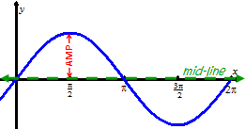
Period: The period of the wave is the horizontal distance of one complete cycle.  $Period= \left(Crest X\right)-\left(Previous Crest X\right)$  $Period= \left(Trough X\right)-\left(Previous Trough X\right)$ | 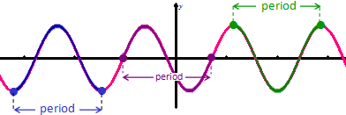
Phase Shift: The amount the wave is shifted right or left  $Phase Shift= \frac{\left(Crest X\right) + \left(Previous Trough X\right)}{2}$ | 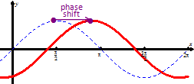
Vertical Shift: The amount the wave is shifted up or down  $Vertical Shift= \frac{(Highest Y + Lowest Y)}{2}$ | 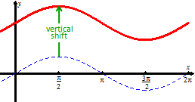

- Find a possible equation of the following graphs.
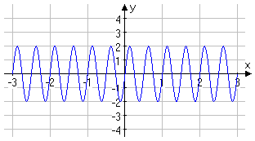
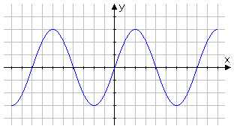
a. b.

Amplitude =

Period =

Phase Shift =

Vertical Shift =
Amplitude =

Period =

Phase Shift =

Vertical Shift =

Student Worksheets: Matthew M. Winking at Phoenix High School SECTION 5-4 p.61

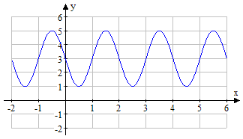
- Find a possible equation of the following graphs.
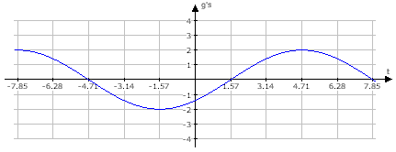
a. b.

Amplitude =

Period =

Phase Shift =

Vertical Shift =
Amplitude =

Period =

Phase Shift =

Vertical Shift =

c. d.
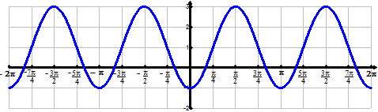
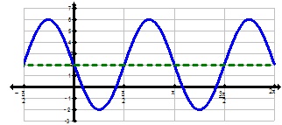

Amplitude =

Period =

Phase Shift =

Vertical Shift =
Amplitude =

Period =

Phase Shift =

Vertical Shift =

Student Worksheets: Matthew M. Winking at Phoenix High School SECTION 5-4 p.62

- Find a possible equation of the following graphs.
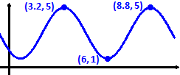
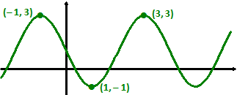
a. b.

Amplitude =

Period =

Phase Shift =

Vertical Shift =
Amplitude =

Period =

Phase Shift =

Vertical Shift =

- The following is a graph of a tuning fork held up to a CBL microphone.
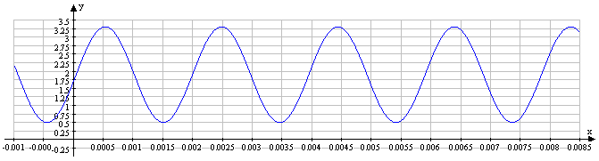

- What is the amplitude? b. What is the Vertical Shift?

c. What is the Period? d. What is a possible Phase Shift?

Student Worksheets: Matthew M. Winking at Phoenix High School SECTION 5-4 p.63

